**A PROJECT REPORT**

**on**

**“ATTENDIFY”**

**Submitted to**

**KIIT Deemed to be University**

**A report submitted in partial fulfillment of the requirement for the award of**

**The degree of**

**BACHELOR’S DEGREE IN**

**INFORMATION TECHNOLOGY**

**BY**

**Shubhra Sinha**

**Akshat Singh**

**Harshit Mishra**

20051367

20051402

20051442

**UNDER THE GUIDANCE OF**

**Dr. Anil Kumar Swain**



**SCHOOL OF COMPUTER ENGINEERING**

**KALINGA INSTITUTE OF INDUSTRIAL TECHNOLOGY**

**BHUBANESWAR, ODISHA - 751024**

**May 2023**

A PROJECT REPORT

on

“Attendify”

Submitted to

KIIT Deemed to be University

In Partial Fulfillment of the Requirement for the Award of

BACHELOR’S DEGREE IN INFORMATION TECHNOLOGY

BY

Shubhra Sinha

Akshat Singh

Harshit Mishra

20051367

20051402

20051442

UNDER THE GUIDANCE OF

Dr.Anil Kumar Swain



SCHOOL OF COMPUTER ENGINEERING

KALINGA INSTITUTE OF INDUSTRIAL TECHNOLOGY

BHUBANESWAR, ODISHA -751024

May 2023

KIIT Deemed to be University

School of Computer Engineering

Bhubaneswar, ODISHA 751024



CERTIFICATE

This is to certify that the project entitled

“Attendify“

submitted by

Shubhra Sinha

Akshat Singh

Harshit Mishra

20051376

20051402

20051442

is a record of bonafide work carried out by them, in the partial fulfillment of the requirement for the award of Degree of Bachelor of Engineering (Computer Science & Engineering OR Information Technology) at KIIT Deemed to be university, Bhubaneswar. This work will be done during 2022-2023, under our guidance.

Date:20 / 04 / 2023

Dr. Anil Kumar Swain

Project Guide

**ACKNOWLEDGEMENT**

We are profoundly grateful to **Dr.** **Anil Kumar Swain** of **Affiliation** for his expert guidance and continuous encouragement to see that this project rights its target from its commencement to its completion. His willingness to give his time so generously has been very much appreciated.

We would also like to thank the staff of KIIT University for encouraging us to do this project with full enthusiasm.

Shubhra Sinha-2001367

Akshat Singh-20051402

Harshit Mishra-20051442

**ABSTRACT**

Attendance management can be a challenging task for teachers, who often have to take attendance of students manually by calling out their names one by one in every class. This process can be time-consuming and prone to errors, especially in large classrooms with a high number of students. Proxy attendance is also a common problem, where students may ask their friends to mark attendance for them, making it difficult for teachers to keep track of who is actually present in the classroom.

To address these challenges, we propose using an intelligent attendance management system that leverages advanced facial recognition technology using machine learning. With this system, students can simply stand in front of a camera, and their faces will be automatically detected and recognized by the software. This process eliminates the need for manual attendance taking and reduces the likelihood of errors or proxy attendance.

The system operates using two primary steps: face detection and face recognition. First, the system detects the presence of a face in the camera's view and identifies the unique facial features of the individual. Then, it matches these features with the pre-existing database of students to determine who is present in the classroom.

This intelligent attendance management system is highly accurate and efficient, reducing the workload for teachers and providing a reliable record of attendance for students. Additionally, the system can be easily integrated with other educational tools, such as learning management systems or grade book software, to create a seamless and comprehensive educational experience. As technology advances, this system can continue to evolve and improve, making attendance management an even more effortless and accurate process for teachers and students alike.

**KEYWORDS-** Attendance System, Facial Recognition Technology, Face Detection, Machine learning,

Contents

| 1 | Introduction | | | 1 |
| --- | --- | --- | --- | --- |
| 2 | Literature Review | | | 2 |
| 3 | Problem Statement | | | 4 |
|  | 3.1 | Project Planning | | 4 |
|  | 3.2 | Project Analysis | | 4 |
|  | 3.3 | System Design | | 4 |
|  |  | 3.3.1 | Hardware Requirements | 4 |
|  |  | 3.3.2 | Software Requirements | 5 |
| 4 | Implementation | | | 6 |
|  | 4.1 | Proposed Model | | 6 |
|  | 4.2 | Testing | | 8 |
|  | 4.3 | Result Analysis | | 10 |
|  | 4.4 | Quality Assurance | | 10 |
| 5 | Standard Adopted | | | 11 |
|  | 5.1 | Design Standards | | 11 |
|  | 5.2 | Coding Standards | | 11 |
|  | 5.3 | Testing Standards | | 11 |
| 6 | Conclusion and Future Scope | | | 13 |
|  | 6.1 | Conclusion | | 13 |
|  | 6.2 | Future Scope | | 13 |
| References | | | | 14 |
| Individual Contribution | | | | 15 |
| Plagiarism Report | | | | 19 |

List of Figures

|  |  |  |
| --- | --- | --- |
|  | 1. **Figure 1-Model Flow Chart …………………………………………….** | **6** |
|  | 1. **Figure 2 – Online data collection form………………………………….** 2. **Figure 3– Encoder File code ……………………………………………..** 3. **Figure 4-Attendance marking file ………………………………………** | **7**  **8**  **9** |

**V.**  **Figure 5 – Model in action & CSV file ………………………………… 10**

*Attendify*

Chapter 1

**I**ntroduction

Attendance management plays a crucial role in any academic institution as it enables educators to monitor student performance and ensure that they are meeting their academic obligations. There are various methods that can be used to manage attendance, including file-based systems and biometric-based systems.

File-based attendance systems are outdated and inefficient. They are known to reduce actual lecture teaching time and make it easy for students to engage in proxy attendance or impersonation attempts. Additionally, they are difficult to manage, especially when dealing with a large student population.

To address these problems, we are developing an intelligent attendance management system that utilizes face recognition technology to mark attendance automatically. This will not only reduce the workload of instructors but also make it easier to manage attendance for a large student population. Our application will also have additional features that will be added in Phase 2. These features will include a website and an app that will help manage daily college activities.

The project will consist of several components that will be integrated into one comprehensive application. Each component of the application will play an integral role in ensuring the successful functioning of the system. We believe that our attendance management system will significantly improve the efficiency and effectiveness of academic institutions, thereby benefiting both educators and students alike.

*School of Computer Engineering, KIIT, BBSR* 1

*Attendify*

Chapter 2

**L**iterature **R**eview

The primary objective is to develop an innovative and sophisticated attendance management system that employs cutting-edge facial recognition technology. The ultimate goal is to address the challenges and limitations of traditional automated attendance systems in various educational institutions and organizations. The proposed approach entails comparing an up-to-date image of a student with a set of deliberately captured images stored in a database, which will be used to verify their real-time attendance. By leveraging advanced facial recognition algorithms, the system can accurately identify students and record their attendance quickly and efficiently. Manual maintenance of attendance records has several drawbacks that impede the effectiveness of this process. Firstly, it takes away valuable classroom time that could otherwise be spent on more productive educational activities. Secondly, manual attendance records are highly vulnerable to proxy attendance and impersonation, leading to inaccurate and unreliable data that compromises the integrity of the attendance tracking system. Therefore, by utilizing a smart attendance management system that incorporates facial recognition technology, educational institutions, and organizations can overcome these hurdles and improve the efficiency and accuracy of their attendance tracking processes.

To resolve this problem of attendance, many attendance management systems have been introduced in recent years. Jain *et. al* [3] developed a desktop-based application in which students are given attendance by clicking a checkbox next to their name and then by clicking the register button to mark their presence. In 2013, Bhalla *et. al* [4] have proposed a blue-tooth based attendance system. Application software installed in the mobile phone enables the registration of the attendance via Bluetooth connection and transfers the notification to the instructor. Works of [5] propose a system for employee attendance based on the fingerprint. The system compares one fingerprint template with all previously stored in the database. In [6], Joardar *et. al* developed an attendance system based on the palm dorsal subcutaneous vein pattern of individuals.

A model as specified by Naveed *et al* [7], is linked with two databases. One is for the faces and the other one is used for marking attendance. The image before the detection and recognition phase, the camera is used to click the face image of the student and perform background and noise removal.

In another implementation of a similar system, Kawaguchi *et al*. [8] proposed a model in which faces and fixed seating positions are matched to images in a database. This is a continuous testing method that uses a streaming video camera to detect student presence in the classroom. They even estimated seating arrangements using various types of calculations. It's a very common architecture implemented with two different cameras, one is used for detecting and the other is used for capturing images. MuthuKalyani *et al.* [9] proposed a different approach for this, using Android devices to perform this task. After the image was captured by the camera, it was subjected to 3D modeling, and canonical techniques were applied to the images for comparison.

*School of Computer Engineering, KIIT, BBSR* 2

*Attendify*

The method developed by Marko Arsenovic et al. [10] uses higher feed rates; Convolutional Neural Network Cascade to implement face recognition, and Convolutional Neural Networks for face embedding. CNNs perform best for larger datasets, or put another way, under running case conditions, the main test was applying these strategies to small datasets. The overall accuracy was 95.02% on a small dataset of the first images of worker faces in the current state.

Kruti Goyal et al. [11], developed a face recognition model using different types of algorithms such as AdaBoost, and Haar Cascades. This model uses MATLAB and OpenCV for its implementation.Facial feature extraction is performed as face localization performed using pattern recognition.

Nusrat Mubin Ara et al. [2] have discussed in their article developments in the field of technologies they use, such as facial recognition, normalization, facial recognition, and neural networks. The authors also wrote about the methodology in which face recognition is performed using Oriented Gradient History, face alignment using face recognition tag estimation, feature extraction using convolutional neural network, and finally scale generation. Although his system found some incorrect predictions,  
achieved more than 95% accuracy. Samuel Lukas et al. [1] integrated the Discrete Wavelet Transform (DWT), Discrete Cosine Transform (DCT), and Radial Basis Function Network (RBFN) detection system in their student attendance system along with their respective mathematical equations. They have illustrated the system design of their proposed framework using a block diagram to show the flow of the process. According to the result of their experiment, since some students were recognized as others, they achieved an accuracy of 82%.

However, most of these systems have corresponding limitations in terms of portability, accessibility, authenticity, or cost. Therefore, trying to overcome the shortcomings of the respective systems leads to the development of a Smart attendance monitoring system(SAMS) based on face recognition. Unlike other biometric and non-biometric attendance systems, facial recognition technology has unique advantages. Each student has a separate facial identity and cannot be faked by mere proxies. In addition, class teachers feel more familiar with the student based on their facial expressions than their names or matriculation number. These works have the following contributions:

* The best face selection method by evaluating face quality and robust face representation using a deep convolutional network.
* Wearable devices based on embedded systems for teaching support.

*School of Computer Engineering, KIIT, BBSR* 3

*School of Computer Engineering, KIIT, BBSR* 5

*Attendify*

Chapter 3

**P**roblem Statement

The main purpose of the Attendify app is not only to use facial recognition to automatically mark the attendance of the students but also to provide a common platform for all college activities. Our objective here is to streamline the attendance marking process which many times is seen as a burden to handle daily. Making a user-friendly UI with unmatched ease of use and management makes it the most compelling alternative to an age-old technique of attendance management and spreading the news of events and other college activities. We can further add even more functionality to make it the only application a college might need for all the various needs.

3.1 **Project Planning**

A platform that is an appealing alternative to an antiquated method of managing attendance and disseminating information about events and other college activities is made possible by creating a user-friendly UI with unsurpassed simplicity of use and maintenance. We can yet add more features to make it the sole application a college would require for all of its requirements.

3.2 **Project Analysis**

To use a facial recognition system to automatically mark the attendance of students and to develop an app to provide and enhance the functionality of a college campus. We intend to make a seamlessly integrated environment for Faculty and student interaction as well as for managing their attendance on the same. This will provide a platform where students will have a better knowledge of what’s happening in the institute, they will be able to communicate to their assigned faculty for some help and guidance also.

3.3 **System Design**

3.3.1 **Hardware Requirements**:

• Intel Core i7 processor 10th gen

• Graphic Card – 2GB

• Ram 8GB

• Camera

*School of Computer Engineering, KIIT, BBSR* 4

*Attendify*

3.3.2 **Software Requirements**:

• Windows 10

• Python 3.7 (Jupyter)

• Visual Studio Code

• OpenCV

• Matplotlib

• NumPy

• Pandas

• Sklearn

• Google Chrome

*School of Computer Engineering, KIIT, BBSR* 5

*Attendify*

Chapter 4

**I**mplementation

The methods and materials required to our platform are described in this section.

4.1 **Proposed Model**

The primary aim of our model is to detect the face and recognize it with maximum accuracy. We will distribute this task into two models for better performance.

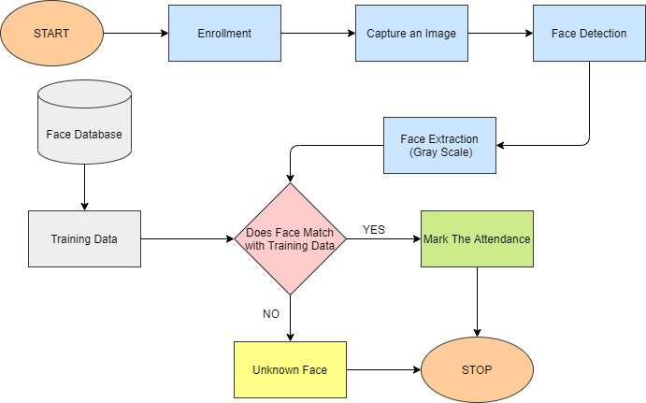

**Figure 1-Model Flow Chart**

**Face Database**

In order to start working on the models, first we will need to create and maintain a face database. The face database stores all the face images in such a way that the data can be retrieved by our model easily.

For data collection, we made an online form that was shared among various class groups. The online form collected basic information from each individual and at last, it asked for a minimum of five images of their face. We also used an offline available dataset which was already collected by another source.

*School of Computer Engineering, KIIT, BBSR* 6

*Attendify*

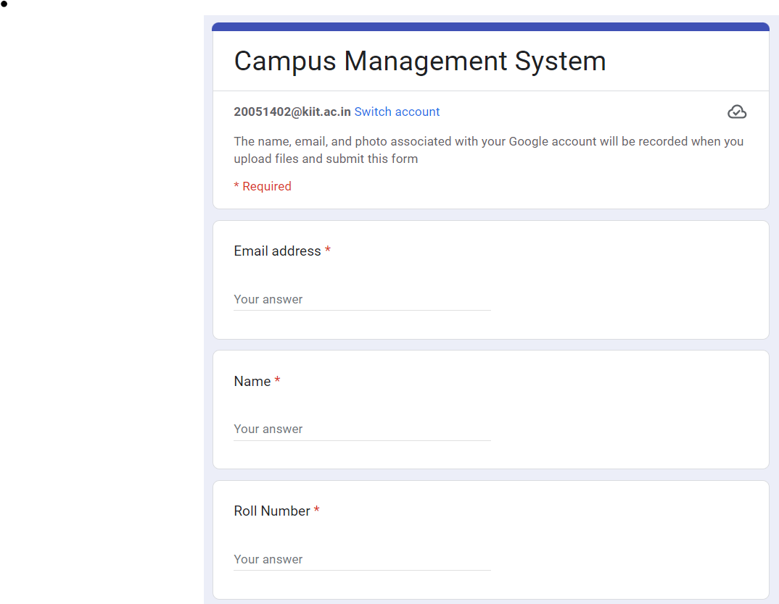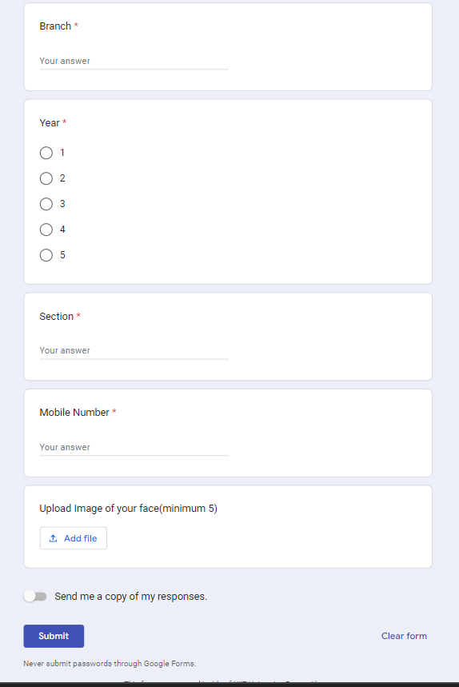

**Figure 2 – Online data collection form**

**Data Preparation**

Once we have collected the data, we’ll need to read it in our model. So, we converted the data into a CSV (comma-separated value) file as it is one of the simplest platform-independent approaches. The CSV file contains only the filename followed by ‘; ‘followed by the label (integer value) of the corresponding image.

Each line in the CSV file will look like this:

/path/image.jpg; 0

*School of Computer Engineering, KIIT, BBSR* 7

*Attendify*

4.2 **Testing**

**Encoder File**

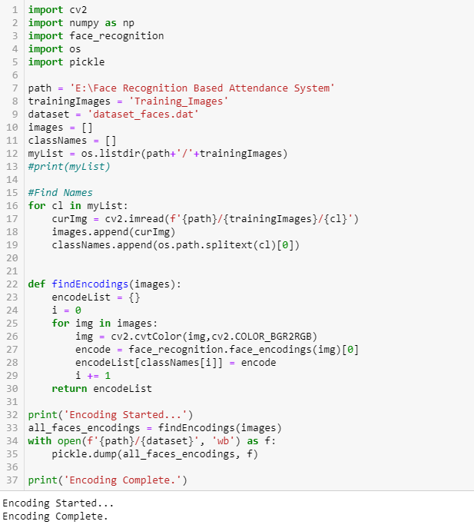

**Figure 3– Encoder File code**

This is the first file of our model which is used to train the model on the given images as well as store the training data in a file for later use. In this file, we have taken use of multiple libraries. CV2 is used to read images from the directory and convert the images into a proper format for pre-processing to take place. We will be labeling each image with the student's roll number so as to make it easier to mark the attendance in the system using these labels only. So now our program reads the images, stores the label mapped with the images, and then cv2 converts these images into proper format. Now we use dlib library’s pre-trained face recognition model which works on a deep learning model to get our encoding for each image. These encodings are what we need to, later on, match to recognize the face. After all the encodings have been calculated we then store these encodings into a .dat file for later use. Storing these encodings enables us to make the attendance marking process go faster as we will not have to retrain the model whenever we need to mark the attendance for any class.

*School of Computer Engineering, KIIT, BBSR* 8

*Attendify*

**Attendance Marking File**

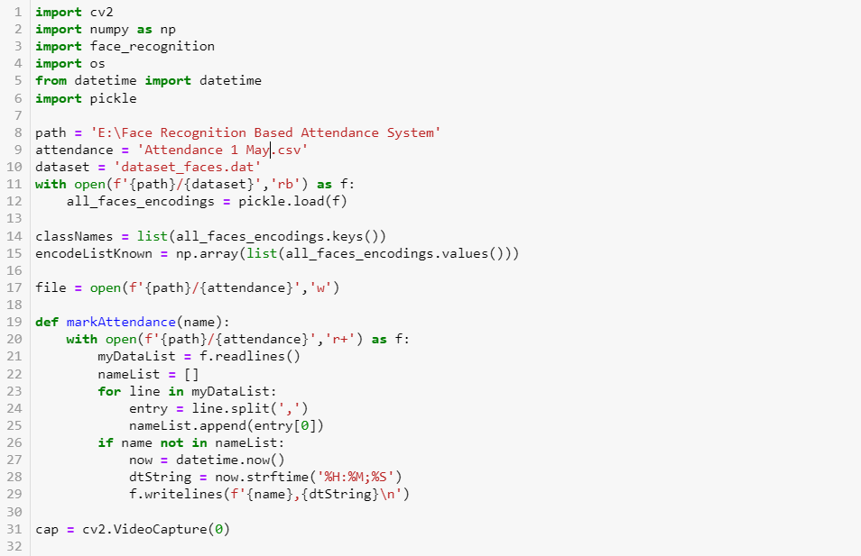

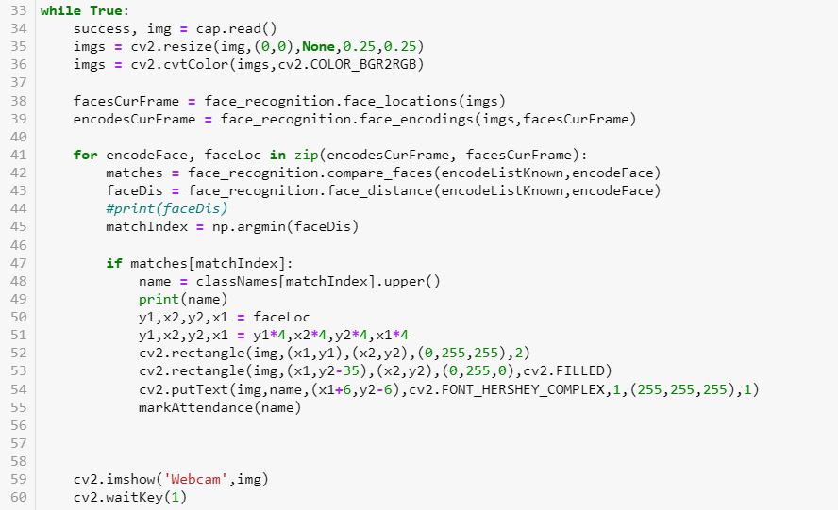

**Figure 4-Attendance marking file**

This is the main working file with the help of which we use the webcam to get the images of students in real-time and use the trained data to recognize the face and mark the attendance of the student with the time stamp in a CSV file. After finding the new encoding from the webcam we compare it with the training model encodings if a match is found we call the markAttendace() function which opens a CSV file and adds a row in it with the student's SAP ID as well as the time stamp. If by any chance the same face is encountered again, we ignore it so as to prevent multiple entries for the same student.

*School of Computer Engineering, KIIT, BBSR* 9

*Attendify*

4.3 **Result Analysis**

**Model in Action**

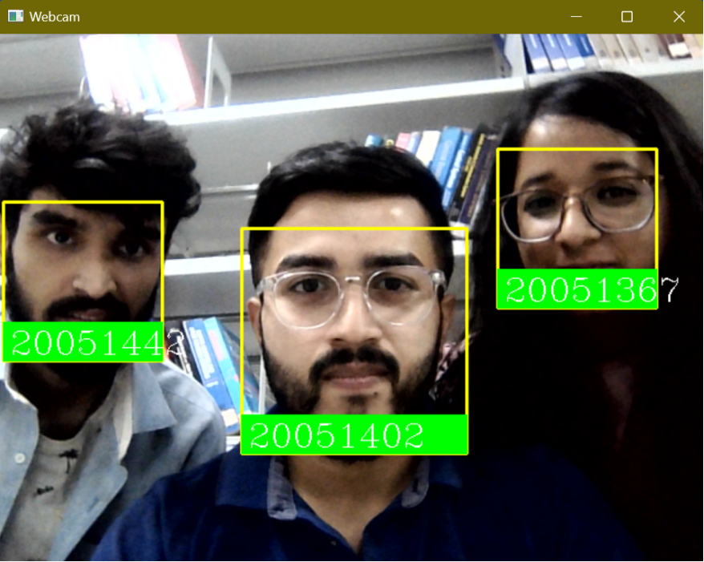

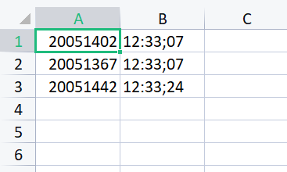

**Figure 5 – Model in action & CSV file**

4.4 **Quality Assurance**

In the working organization, if some department is there to verify the quality of your work, they can produce a certificate or guidelines followed.

* Unit-Testing
* Black-Box Testing
* White-Box Testing

*School of Computer Engineering, KIIT, BBSR* 10

*Attendify*

Chapter 5

**S**tandards **A**dopted

5.1 **Design Standards**

A software project's design is a crucial undertaking that needs considerable planning and thought. Here are a few guidelines for designing software projects:

* Clearly State Project Objective
* Utilize Proper Architecture
* Design a Modular Structure
* Adhere to Industry Standards
* Think about Scalability
* Make maintenance plans
* Implement design patterns
* Verification Control

5.2 **Coding Standards**

Coding standards are collections of coding rules, guidelines, and best practices. A few of the coding standards are:

* Try to write as few lines as you can.
* Adopt sensible naming practices.
* Divide code snippets from the same section into paragraphs.
* Indent control structures at their beginning and end using indentation. Indicate the connection between them in detail.
* Avoid calling long functions. A single function should, ideally, complete a single task

5.3 **Testing Standards**

There are some ISO and IEEE standards for quality assurance and testing of the product. The standards followed for testing and verification of our project work include

(1)Unit Testing: The most compact testable unit of a software program is tested. Developers carry it out throughout the coding phase.

*School of Computer Engineering, KIIT, BBSR* 11

*Attendify*

(2)Regression Testing: Regression testing verifies that no new mistakes have been added to the software after the adjustments have been made by testing the modified portions of the code and the portions that may be impacted due to the alterations.

*School of Computer Engineering, KIIT, BBSR* 12

*Attendify*

Chapter 6

**C**onclusion and **F**uture Scope

6.1 **Conclusion**

Our proposed model of automatic attendance marking through the use of Python's Deep learning model for face detection is a significant technological achievement that has the potential to revolutionize the process of attendance-taking. The traditional method of taking attendance in a classroom involves a teacher calling out each student's name and manually ticking off their presence on a sheet of paper. This process can be time-consuming and prone to errors.

Our model simplifies this process by using facial recognition technology to identify each student as they enter the classroom. The system captures a photo of each student's face, compares it to a database of known faces, and automatically marks their attendance accordingly. This approach saves valuable lecture time that would otherwise be spent on attendance-taking, allowing the teacher to focus on delivering more content or answering questions and doubts.

The potential benefits of this technology are clear, and more educational institutions will likely adopt it in the future to improve the efficiency and accuracy of attendance-taking.

6.2 **Future Scope**

Using a simple website, users will be able to view their attendance and access a common platform for both teachers and students. The website will allow teachers to start the camera to mark the attendance of the students, and students can easily review their attendance records later on.

In the future, this attendance system could be enhanced with new features such as integration with biometric technologies or machine learning-based analytics. Additionally, mobile app integration could provide an even more convenient way for users to access their attendance records and for teachers to mark attendance.

The system could also incorporate IoT devices or augmented reality to create a more interactive and engaging experience for users. Furthermore, gamification elements could be introduced to motivate students to improve their attendance and engagement.

*School of Computer Engineering, KIIT, BBSR* 13

*Attendify*

**References**

[1] S. Lukas, A. R. Mitra, R. I. Desanti, and D. Krisnadi, "Student Attendance System in Classroom Using Face Recognition Technique", ICTC 2016, 2016.

[2] N. M. Ara, N. S. Simul, and M. S. Islam, "Convolutional Neural Network Approach for Vision-Based Student Recognition System", 2017 20th International Conference of Computer and Information Technology (ICCIT) 22-24 December 2017, 2017.

[3] S. K. Jain, U. Joshi, and B. K. Sharma, "Attendance management system" in Masters Project Report Rajasthan Technical University, Kota, 2011.

[4] V. Bhalla, T. Singla, A. Gahlot and V. Gupta, "Bluetooth based attendance management system", International Journal of Innovations in Engineering and Technology (IJIET), vol. 3, no. 1, pp. 227-233, 2013.

[5] S. S. Mahat and S. Mundhe, "Proposed framework: College attendance management system with mobile phone detector", International Journal of Research in IT and Management, vol. 5, no. 11, pp. 72-82, 2015.

[6] S. Joardar, A. Chatterjee and A. Rakshit, "A real-time palm dorsa subcutaneous vein pattern recognition system using collaborative representation-based classification", IEEE Transactions on Instrumentation and Measurement, vol. 64, no. 4, pp. 959-966, 2015.

*School of Computer Engineering, KIIT, BBSR* 14

*Attendify*

[7] N. Khan and Balcoh, "Algorithm for efficient attendance management: Face recognition based approach", JCSI International Journal of Computer Science, 2012.

[8] KAWAGUCHI and Yohei, "Face Recognition-based Lecture Attendance System", The 3rd AEARU Workshop on Network Education, 2005.

[9] K MuthuKalyani, "Smart Application For AMS using Face Recognition", CSEIJ 2013, 2013.

[10] M. Arsenovic, S. Skadojevic, and A. Anderla, "FaceTime- Deep Learning Based Face Recognition Attendance system", IEEE 15th International Symposium on Intelligent Systems and Informatics, 2017.

[11] K. Goyal, K. Agarwal, and R. Kumar, "Face Detection and tracking using OpenCV", International Conference on Electronics Communication and Aerospace Technology ICECA 2017, 2017.

*School of Computer Engineering, KIIT, BBSR* 15

*Attendify*

**INDIVIDUAL CONTRIBUTION REPORT:**

**Attendify**

AKSHAT SINGH

20051402

**Abstract:** Monitoring student attendance is a crucial aspect of any institution for assessing student performance. However, manually taking attendance during lectures can be time-consuming, taking up to 20% of the lecture time. This time could be better spent elsewhere. Our goal is to simplify the attendance marking process, which can often be perceived as a daily burden. To achieve this, we propose implementing a face recognition attendance system that will automatically mark attendance, thereby reducing the instructor's workload.

**Individual contribution and findings:** played a key role in providing coding solutions, software support, and data management. This involved evaluating the software to meet the user’s requirements. I worked on implementing various codes to automate the attendance processes, which greatly reduced the time and effort required to take attendance manually. My contribution to the project was vital in making the attendance processes seamless, efficient, and reliable.

**Individual contribution to project report preparation:** my contributions included drafting the introduction and writing the abstract. In addition, I was responsible for identifying and elaborating on all the problem statements and system requirements. By taking up these tasks, I played a vital role in setting up the project, ensuring that the goals and objectives were clear and well-defined. My efforts contributed to the smooth running of the project and helped in achieving its ultimate goals.

**Individual contribution to project presentation and demonstration:** In addition to my other contributions, I took charge of the coding standards employed in the project. I also shared the project's objectives and outlined its potential future possibilities. By doing so, I ensured that all members had a clear understanding of the project's scope and its technical aspects, which helped facilitate effective collaboration and decision-making.

Full Signature of Supervisor: Full signature of the student:

……………………………. ……………………………..

*School of Computer Engineering, KIIT, BBSR* 16

*Attendify*

**Attendify**

SHUBHRA SINHA

20051367

**Abstract:** Monitoring student attendance is a crucial aspect of any institution for assessing student performance. However, manually taking attendance during lectures can be time-consuming, taking up to 20% of the lecture time. This time could be better spent elsewhere. Our goal is to simplify the attendance marking process, which can often be perceived as a daily burden. To achieve this, we propose implementing a face recognition attendance system that will automatically mark attendance, thereby reducing the instructor's workload.

**Individual contribution and findings:** played a key role in collecting image data and conducting surveys to gain a comprehensive understanding of the current scenario. Afterward, I meticulously analyzed all the datasets and their usefulness in obtaining the desired results. Helped in debugging and deployment of the code.

**Individual contribution to project report preparation:** I was responsible for contributing to the literature review section. This involved conducting thorough analyses of various reference papers, synthesizing their contents, and presenting a comprehensive summary of their findings clearly and concisely. Additionally, I took charge of preparing the section on standards adopted, ensuring that all necessary information was included and presented accurately.

**Individual contribution to project presentation and demonstration:** In the presentation, I created the section that outlined the features of our model, the technology used to develop the model, and finally the functional and non-functional requirements, along with the constraints, and added a detailed final touch to the presentation

Full Signature of Supervisor: Full signature of the student:

……………………………. ……………………………..

*School of Computer Engineering, KIIT, BBSR* 17

*Attendify*

**Attendify**

HARSHIT MISHRA

20051442

**Abstract:** Monitoring student attendance is a crucial aspect of any institution for assessing student performance. However, manually taking attendance during lectures can be time-consuming, taking up to 20% of the lecture time. This time could be better spent elsewhere. Our goal is to simplify the attendance marking process, which can often be perceived as a daily burden. To achieve this, we propose implementing a face recognition attendance system that will automatically mark attendance, thereby reducing the instructor's workload.

**Individual contribution and findings:** I played a role in developing the design solution to solve our attendance marking and maintenance problem and also helped in training and testing the model.

**Individual contribution to project report preparation:** My contributions to the project also included preparing major report writing areas, such as model training and testing, as well as implementing techniques to ensure their success. Also contributed to the literature survey section.

**Individual contribution to project presentation and demonstration:** I prepared the part of the PowerPoint presentation that contained the problem statement, introduction, and abstract of the project, which I explained during the presentation.

Full Signature of Supervisor: Full signature of the student:

……………………………. ……………………………..

*School of Computer Engineering, KIIT, BBSR* 18

TURNITIN PLAGIARISM REPORT

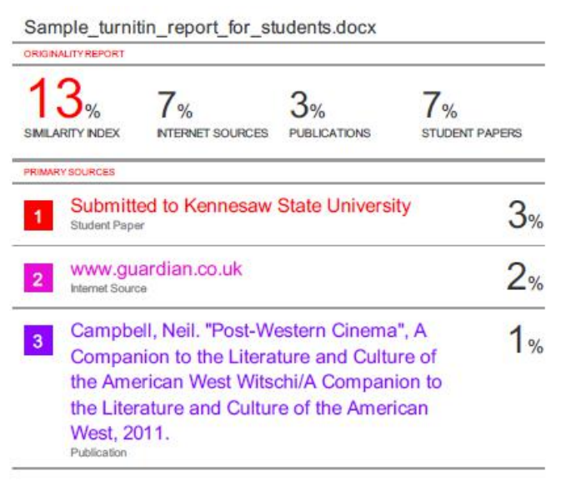

*School of Computer Engineering, KIIT, BBSR* 19